Electricity - 05
CLASS 10 - SCIENCE

 | Section A
1 | If in figure, R$​_{1}$ = 10 $Ω$ , R $​_{2}$ = 40 $Ω$ , R $​_{3}$ = 30 $Ω$ , R $​_{4}$ = 20 $Ω$ , R $​_{5}$ = 60 $Ω$ , and a 12 V battery is connected to the arrangement. Calculate 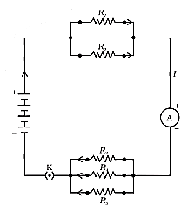  - the total resistance in the circuit, and  - the total current flowing in the circuit. | [3]
2 | In a circuit find  - total resistance  - current shown by ammeter. 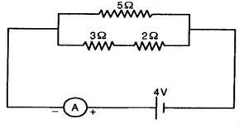 | [3]
3 | The current flowing through a resistor connected in a circuit and the potential difference developed across its ends are as shown in the diagram by milliammeter and voltmeter readings respectively:  - What are the least counts of these meters?  - What is the resistance of the resistor? 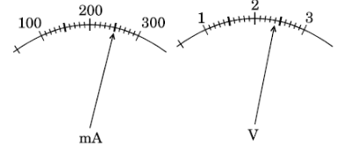 | [3]
4 | An electrician puts a fuse of rating 5 A in that part of domestic electrical circuit in which an electric heater of rating 1.5 kW, 220 V is operating. What is likely to happen in this case and why? | [3]
5 | A heater coil connected to 200 V has a resistance of 80$Ω$ . If the heater is plugged in for the time t such that 1 kg of water at 20°C attains a temperature of 60°C. Find  - the power of heater.  - the heat absorbed by waterand the value of t in seconds. | [3]
6 | Study the following circuit and answer the questions that follows: 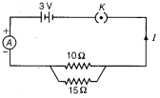  - How much current is flowing through  - 10$Ω$ and  - 15$Ω$ resistor?  - What is the ammeter reading? | [3]
7 | Calculate:  - the effective resistance of the circuit and the current in the circuit  - Potential difference across 10$Ω$ resistor of a circuit shown in the figure.  - 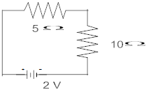 | [3]
8 | Two resistors of resistances R and 2R are connected in series is an electrical circuit? Calculate the ratio of the electric power consumed by R and 2R? | [3]
9 | Three students X, Y and Z while performing the experiment to study the dependence of current on the potential difference across a resistor, connect the ammeter (A), the battery (B), the key (k) and the resistor (R) in series, in the following three different orders.  - X$→$ B, K, R, A, B  - Y$→$ B, A, K, R, B  - Z$→$ B, R, K, A, B  Who has connected them in the correct order? | [3]
10 | - List the factors on which the resistance of a uniform cylindrical conductor of a given material depends.  - The resistance of a wire of 0.01 cm radius is 10$Ω$ . If the resistivity of the wire is 50 $×$ 10 $​^{−8}$ $Ω$ m, find the length of this wire. | [3]
11 | - Several electric bulbs designed to be used on a 220V electric supply line are rated 10W. How many lamps can be connected in parallel with each other across the two wires of 220V line if the maximum allowable current is 5A?  - Calculate the cost of seeing 2 movies on colour T.V. daily for the month of September.Given wattage of colour T.V. = 60 W, duration of each movie is 2 hours 30 min and 1kWh costs Rs. 4 | [3]
12 | Find the equivalent resistance of the following combinations of resistors:  - 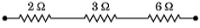  - 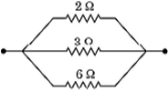 | [3]
13 | A battery of 9 V is connected in series with resistorsof$0.2Ω,0.3Ω,0.4Ω,0.5Ωand12Ω$ respectively. How much current would flow through the $12Ω$ resistor? | [3]
14 | - A wire of resistance 2 has been connected to a source of 50 V as its two ends. What is the current flowing through the wire?  - An electric kettle rated at 220 V, 2.2 kW works for 3h. Calculate the energy consumed and the current drawn. | [3]
15 | Five resistors are connected in a circuit as shown in figure. Find the ammeter reading when the circuit is closed. 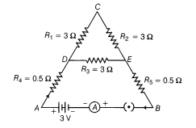 | [3]
16 | A battery made of 5 cells, each of 2 V and have internal resistance 0.1$Ω$ , 0.2 $Ω$ , 0.3 $Ω$ , 0.4 $Ω$ and 0.5 $Ω$ is connected across 10 $Ω$ resistance. Draw circuit diagram and calculate the current flowing through 10 $Ω$ resistance? | [3]
17 | - A lamp consumes 50 W and is lighted 2 h daily in month of April. How many units of electric energy is consumed?  - An electric iron of resistance 20$Ω$ takes a current of 5A. Calculate the heat developed in 30s. | [3]
18 | A metallic wire of resistance R is cut into ten parts of equal length. Two pieces each arejoined in series and then five such combinations are joined in parallel. What will be the effective resistance of the combination? | [3]
19 | An electric geyser rated at 1500 W, 250 V is connected to a 250 V line mains. Solve  - the electric current drawn by it. and the energy consumed by it in 50 h.  - cost of energy consumedif each unit costs Rs6. | [3]
20 | Should the resistance of an ammeter be low or high? Give reason. | [3]
21 | What is the current through each of the resistances in the following circuit ? 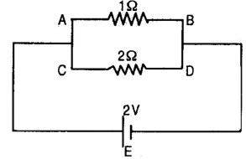 | [3]
22 | - What is the heating effect of electric current?  - Write an expression for the amount of heat produced in a resistor when an electric current is passed through it stating the meanings of the symbols used.  - Name two appliances based on heating effect of electric current. | [3]
23 | In the circuit diagram given in figure, suppose the resistors R$​_{1}$ , R $​_{2}$ and R $​_{3}$ have the values 5 $Ω$ , 10 $Ω$ , 30 $Ω$ , respectively, which have been connected to a battery of 12 V. Calculate: 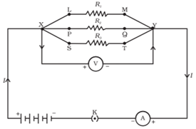  - the current through each resistor,  - the total current in the circuit, and the total circuit resistance. | [3]
24 | - Calculate the resistance of a metal wire of length 2 m and area of cross - section 1.55$×$ 10 $​^{−6}$ m $​^{2}$ . (Resistivity of the metal is 2.8 $×$ 10 $​^{−8}$ $Ω$ m)  - Why are alloys preferred over pure metals to make the heating elements of electrical heating devices? | [3]
25 | - Write the relationship between electrical resistance and electrical resistivity for a metallic conductor of cylindrical shape. Hence derive the SI unit of electrical resistivity.  - Find the resistivity of the material of a metallic conductor of length 2 m and area of cross - section 1.4$×$ 10 $​^{−6}$ m $​^{2}$ . The resistance of the conductor is 0.04 ohm. | [3]
26 | A battery E is connected to three identical lamps P, Q and R as shown in figure: 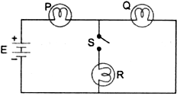  Initially the switch S is kept open and the lamp P and Q are observed to glow with same brightness. Then switch S is closed. How will the brightness of the glow of bulbs P and Q will change? Justify your answer. | [3]
27 | The given figure shows a battery, a switch and two bulbs. Complete the diagram to show the electric connections of the bulbs to the battery. How have you joined the bulbs? Give a reason. 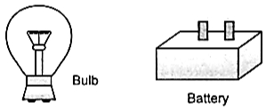  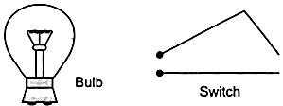 | [3]
28 | - An electric heater is rated at 2kW. Electrical energy costs$₹$ 4 per kWh. What is the cost of using the heater for 3 hours?  - You have two electric lamps having rating 40W, 220V and 60W, 220V. Which of the two has a higher resistance? Give reason for your answer. If these two lamps are connected to a source of 220V, which will glow brighter? | [3]
29 | - How much current will an electric bulb draw from a 220 V source, if the resistance of the bulb filament is 1200$Ω$ ?  - How much current will an electric heater coil draw from a 220 V source, if the resistance of the heater coil is 100$Ω$ ? | [3]
30 | The following circuit diagram shows three resistors 2Ω, 4Ω, RΩconnected to a battery of e.m.f. 2V and internal resistance 3Ω. A main current of 0.25 A flows through the circuit.  - What is the P.D. across 4 Ω resistor.  - Calculate P.D. across the internal resistance of the cell. 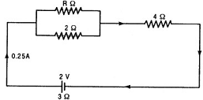 | [3]
31 | In the circuit diagram given here,calculate - 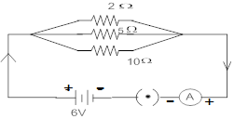  - The total effective resistance and the total current  - The current through each resistor | [3]
32 | How can three resistors of resistance 2Ω, 3Ω and 6Ω be connected to give a total resistance of (a) 4Ω; (b) 1Ω? | [3]
33 | - A wire of resistance 2 has been connected to a source of 50 V as its two ends. What is the current flowing through the wire?  - An electric refrigerator rated 400 W operates 8 hour/day. What is the cost of the energy to operate it for 30 days at$₹$ 3.00 per kWh? | [3]
34 | - It would cost a man$₹$ 3.50 to buy 1.0 kW h of electrical energy from the Main Electricity Board. His generator has a maximum power of 2.0 kW. The generator produces energy at this maximum power for 3 hours. Calculate how much it would cost to buy the same amount of energy from the Main Electricity Board.  - A student boils water in an electric kettle for 20 minutes. Using the same mains supply he wants to reduce the boiling time of water. To do so should he increase or decrease the length of the heating element? Justify your answer. | [3]
35 | - When a 12 V battery is connected across an unknown resistor, there is a current of 2.5 mA in the circuit. Find the value of the resistance of the resistor?  - 320J of heat is produced in 10 s in a 2$Ω$ resistor. Find the amount of current flowing through the resistor. | [3]
36 | - A student wants to use an electric heater, an electric bulb and an electric fan simultaneously.How should these gadgets be connected with the mains? Justify your answer giving three reasons.  - What is an electric fuse? How is it connected in a circuit? | [3]
37 | Draw a schematic diagram of a circuit consisting of a battery of three cells of 2 V each, a 5$Ω$ resistor, an 8 $Ω$ resistor, and a 12 $Ω$ resistor and a plug key, all connected in series. Now, connect the ammeter to measure the current through the resistors and a voltmeter to measure the potential difference across the 12 $Ω$ resistors. What would be the readings in the ammeter and the voltmeter? | [3]
38 | List three advantages of connecting electrical appliances in parallel with the mains instead of connecting them in series. | [3]
39 | A circuit diagram is given as shown below: 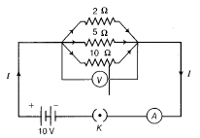  Calculate  - the total effective resistance of the circuit.  - the total current in the circuit and the current through each resistor. | [3]
40 | The following circuit diagram shows three resistors 2Ω, 4Ω, RΩconnected to a battery of e.m.f. 2V and internal resistance 3Ω. A main current of 0.25 A flows through the circuit.  - What is the potential difference across RΩand 2Ω resistors ?  - Calculate the value of R.  | [3]
41 | - Write the formula for determining the equivalent resistance between A and B of the two combinations (I) and (II) of three resistors R$​_{1}$ , R $​_{2}$ and R $​_{3}$ arranged as follows:  - 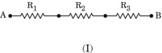  - 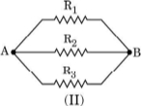  - If the equivalent resistance of the arrangements (I) and (II) are R$​_{s}$ and R $​_{p}$ respectively, then which one of the following VI graphs is correctly labelled? Justify your answer.  - 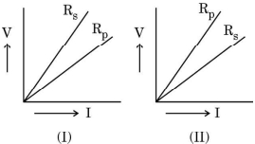 | [3]
42 | Consider the following circuit: 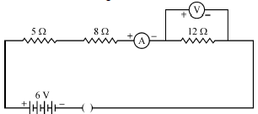  What would be the readings of the ammeter and the voltmeter when key is closed? Give reason to justify your answers. | [3]
43 | For a heater, rated 4 kW and 220 V, calculate the following:  - The current  - Energy consumed in 2 hours  - If 1 kWh is priced at$₹$ 4.50, then the cost of energy consumed | [3]
44 | - How will you infer with the help of an experiment that the same current flows through every part of a circuit containing three resistors in series connected to a battery?  - Consider the given circuit and find the current flowing in the circuit and potential difference across the 15$Ω$ resistors when the circuit is closed.  - 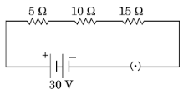 | [3]
45 | In the given circuit determine the value of:  - The Total resistance of the circuit  - Current flowing through the ammeter. 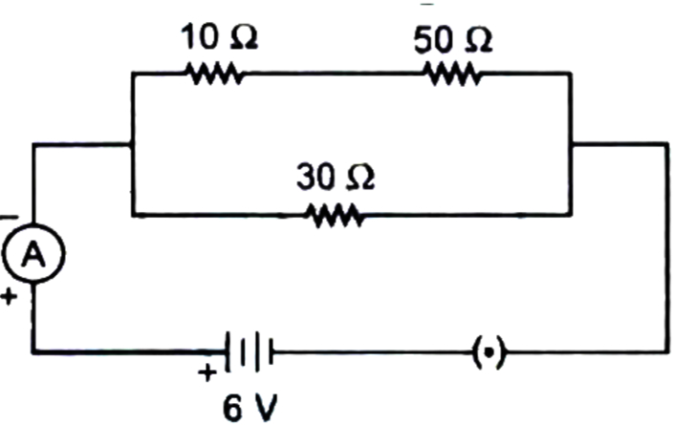 | [3]
46 | - What is the meaning of electric power of an electrical device? Write its SI unit.  - An electric kettle of 2 kWis used for 2h. Calculate the energy consumed in (i) kilowatt hour and (ii) joules. | [3]
47 | - Find the value of currentin the circuit given as below: 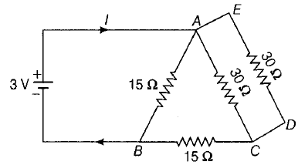  - You have four resistors of 8$Ω$ each. Show how would you connect these resistors to have effective resistance of 8 $Ω$ ? | [3]
48 | - Define Electric Power and write its SI unit.  - Two bulbs rated 100 W; 220 V and 60 W; 220 V are connected in parallel to an electric mains of 220 V. Find the current drawn by the bulbs from the mains. | [3]
49 | - An electrical bulb is rated 40 W, 220 V. How many bulbs can be connected in parallel with each other across the two wires of 220 V line, if the maximum allowable current is 6 A?  - Which uses more energy, a 250 WTV set for 1 hour or a 1,200 Wtoaster for 10 minutes ? | [3]
50 | In the figure given below, a simple electric motor is shown: 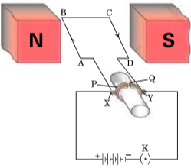  As shown in the figure, the current in the coil ABCD flows from A to B in the arm AB and C to D in the arm CD.  - State the directions in which the arms AB and CD will experience a force.  - Identify the part of the electric motor that reverses the flow of current in the coil ABCD and write its name.  - After the reversal of the flow of current in the coil ABCD, state the directions in which the arms AB and CD will experience a force.  - Name the rule which is applied to determine the direction of force on a current carrying conductor placed in a magnetic field. | [3]
51 | - Calculate the cost of seeing 2 movies on colour T.V. daily for the month of September. Given wattage of colour T.V. = 60 W, duration each movie is 2 hours 30 min and 1kWh costs$₹$ 4.  - An electric kettle rated at 220 V, 2.2 kW works for 3h. Calculate the energy consumed and the current drawn. | [3]
52 | A household uses the following electric appliances:  - The refrigerator of rating 400 W for 10 h each day and Two electric fans of rating 80 W each for 6 h daily.  - Six electric tubes of rating 18 W each for 6 h daily.Calculate the electricity bill for the household for the month of June, if the cost of electrical energy is Rs3 per unit. | [3]
53 | Given in fig. is the circuit diagram in which three resistors of 1Ω, 2Ω and 3Ω are connected to cell of e.m.f. 2V and internal resistance 0.5 Ω.  - Calculate the total resistance of the circuit.  - What is the reading of ammeterand What will be ammeter reading if an exactly similar cell is connected in series with the given cell ? 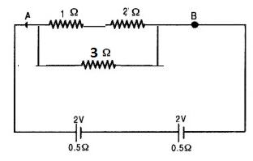 | [3]
54 | Find out the following in the electric circuit given in Figure 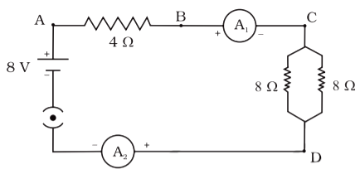  - The potential difference across 4$Ω$ resistance  - The power dissipated in 4$Ω$ resistor | [3]
55 | You are provided with a resistor, a key, an ammeter, a voltmeter, four cells of 1.5 Veach and few connecting wires. Using these circuit components, draw a labelled circuit diagram to show the setup to study the Ohm’s law.State the relationship between potential difference (V) across the resistor and the current (I) flowing through it. Also draw V - I graph, taking V on the X - axis. | [3]
56 | What are the advantages of connecting electrical devices in parallel with the battery instead of connecting them in series? | [3]
57 | Compare the power used in 2$Ω$ resistor in each of the following circuits  - a 6V battery in series with 1$Ω$ and 2 $Ω$ resistors and  - a 4V battery in parallel with 12$Ω$ and 2 $Ω$ resistors. | [3]
58 | - An electric motor takes 5A from a 220V line. Determine the power of the motor and the energy consumed in 2 h.  - An electric heater of resistance 8$Ω$ draws 15A from service mains for 2 hours. Calculate the rate at which heat is developed in the heater. | [3]
59 | - Two electric lamps rated 100 W,220 V and 60 W,220 V are connected in parallel to electric mains supply. Calculate thecurrent drawn from the mains if the supply voltage is 220 V?  - A lamp consumes 50 W and is lighted 2 h daily in month of April. How many units of electric energy is consumed ? | [3]
60 | The values of current I flowing through a resistor for the corresponding values of potential difference V across it are given below: 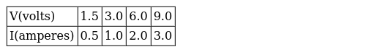  - Plot a graph between V and I.  - Why should this graph pass through the origin?  - Name and state the law which is represented by the graph. | [3]
61 | What possible values of the resultant resistance one can get by combining two resistances one of value 2Ω and the other 6Ω ? | [3]
62 | Judge the equivalent resistance when the following are connected in parallel (a) 1$Ω$ and 10 $​^{6}$ Ω (b) 1 $Ω$ and 10 $​^{3}$ $Ω$ and 10 $​^{6}$ $Ω$ | [3]
63 | Two lamps, one rated 100 W at 220 V and the other 60 W at 220 V, are connected in parallel to electric mains supply of 220 V. Draw a circuit diagram to show this arrangement and calculate the current drawn by the two lamps from the mains. | [3]
64 | Define the term electric power. An electric device of resistance R when connected across an electric source of voltage V draws a current I. Derive an expression for the power in terms of resistance R and voltage V. What is the power of a device of resistance 400$Ω$ operating at 200 V? | [3]
65 | An electric lamp, whose resistance is 20$Ω$ , and a conductor of 4 $Ω$ resistance are connected to a 6 V battery in figure. Calculate (a) the total resistance of the circuit, (b) the current through the circuit, and (c) the potential difference across the electric lamp and conductor. 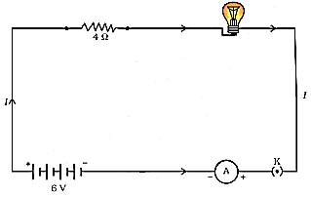 | [3]
66 | - Several electric bulbs designed to be used on a 220V electric supply line are rated 10W. How many lamps can be connected in parallel with each other across the two wires of 220V line if the maximum allowable current is 5A?  - A heater coil connected to 200 V has a resistance of 80$Ω$ . If the heater is plugged in for the time t such that 1 kg of water at 20°C attains a temperature of 60°C. Find the power of the heaterand the heat absorbed by water. | [3]
67 | - Three resistors R$​_{1}$ , R $​_{2}$ and R $​_{3}$ are connected in parallel and the combination is connected to a battery, an ammeter, a voltmeter and a key. Draw suitable circuit diagram to show the arrangement of these circuit components along with the direction of current flowing.  - Calculate the equivalent resistance of the following network: 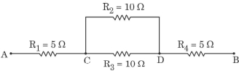 | [3]
68 | - In the following figure, three cylindrical conductors A, B and C are shown along with their lengths and areas of cross - section. If these three conductors are made of the same material and R$​_{A}$ , R $​_{B}$ and R $​_{C}$ be their respective resistances, then find (a) $\frac{R_{A}}{R_{B}}$ , and (b) $\frac{R_{A}}{R_{C}}$ .  - 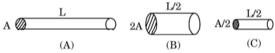  - If the conductor A is made of copper and the conductor C is made of constantan (alloy of copper and nickel), then which one of the two will have more electrical resistance and why? | [3]
69 | The length of different metallic wires, but of the same area of cross - section and made of the same material are given below:Wire - Length A - 1 m B - 1.5 m C - 2.0 m (i) Out of these threewires, which wire has higher resistance? (ii) Which wire has higher electrical resistivity? Justify your answer. | [3]
70 | Show how would you join three resistors, each of resistance 9$Ω$ so that the equivalent resistance of the combination is  - 13.5$Ω$  - 6$Ω$ ? | [3]
71 | - An electric lamp of 100 ohms,a toaster of resistance 50 ohms and a water filter of resistance 500 ohms are connected in parallel to a 220V source. what is the resistance of the electric iron connected to the same source that takes as much current as all the three appliances and what is the current through it?  - Which uses more energy, a 250 WTV set for 1 hour or a 1,200 Wtoaster for 10 minutes? | [3]
72 | For the circuit shown in fig. what is the value of  - total resistance and current through 6W resistor  - potential difference across 12 Wresistor? 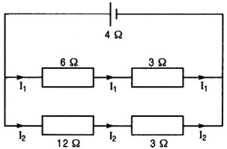 | [3]
73 | - State Joule’s law of heating. Express it mathematically when an appliance of resistance R is connected to a source of voltage Vand the current I flows through the appliance for a time t.  - A 5$Ω$ resistor is connected across a battery of 6 volts. Calculate the energy that dissipates as heat in 10s. | [3]
74 | For the circuit shown in the given diagram: 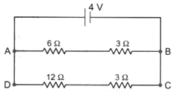  What is the value of  - current through 6$Ω$ resistor?  - potential difference across 12$Ω$ resistor? | [3]

